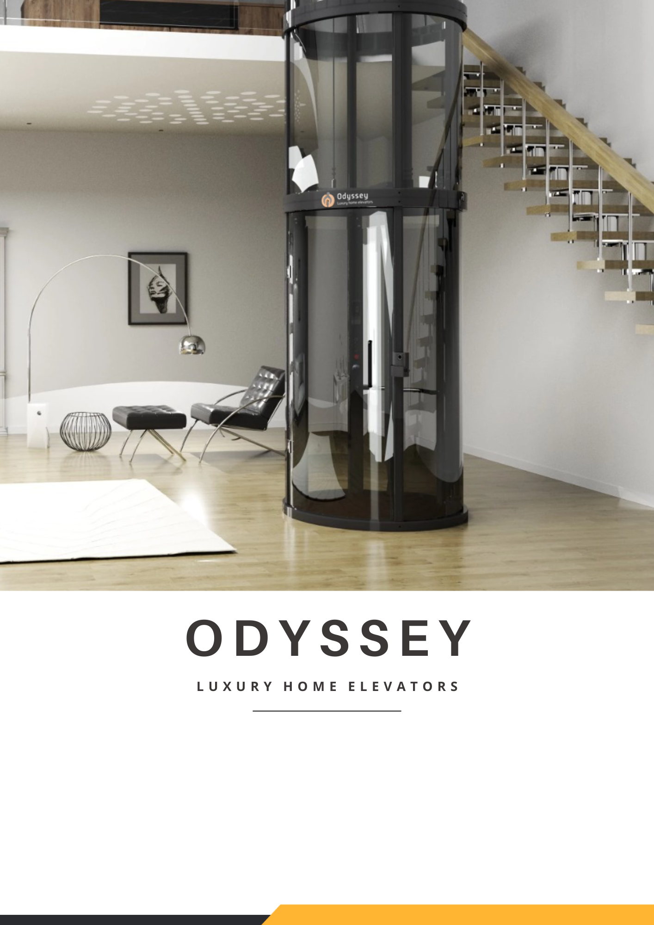

Name:Mr.Ganesh

Quote No: OY819
Place: Theni
PH:9442251251

Model: Orbit Std G+2
Date 27-05-2026

About US
Odyssey Elevators is a Specialist in premium Electric circular home lifts, offering European-imported elevators built on next‑generation ‘Quantum Electric’ technology for discerning homeowners across India. Every Odyssey home elevator is engineered to deliver a silent, smooth and energy‑efficient ride, while adding a striking panoramic design element that enhances the aesthetics and value of luxury villas, bungalows and penthouses.

Odyssey systems are fully compliant with European safety regulations, manufactured in accordance with the Machinery Directive 2006/42/EC and EN 81‑41, and supplied with complete CE certification for peace of mind.

Every model integrates an advanced 8‑layer safety architecture that includes magnetic door locking, mechanical rail brakes, speed governors, intelligent sensors and additional protection systems designed to safeguard children, seniors and guests at all times. From concept to commissioning, Odyssey focuses on reliability, safety and long‑term service support, positioning itself as one of India’s most trusted circular home elevator brands for future‑ready, barrier‑free living.
Welcome to the future.

Lift Specification – ORBIT 1100
Model Name | ORBIT 1100
Colour | Grey (RAL 7016)
Rated Load | 200Kg
Electrical Requirement | 230 Volts, Single Phase / 400 Volts, Three Phase
Speed | 0.15 m/s (Single Phase)
Technology | Electric
Stops | G+2 (3 stops)
Door Type | Panoramic Door (Manual)
Safety Feature | 1.Fully Compliant with Machine Directive Code 2006/42/EC & European Norms EN81  2. Automatic Descent to ground level at safer speed in the event of power failure.  3. Mechanical Emergency brakes within 5cm of over travel. 4.Electro Mechanical interlocks at each landing and Alarm.  5. Smart Beam Door Sensors
Plan Size | External Diameter 1100mm
Penetration required to install through floors and ceiling | External Diameter +50mm
Cabin Height | 2010 mm
Minimum Headroom | 2850 mm
Pit Depth | 125 mm
Total Travel Height | 7000 mm
Entrance Width Opening | 600 mm
Internal Cabin Height | 2000 mm
Internal Cabin Diameter | 800 mm
Door Openings | Same Side
Name: Signature

Term of Sale
Actual Price |  | Offer Price
Total Lift Cost | Rs.15,65,000/- | Rs.22,03,390/-
GST 18 % | Rs.2,81,700/- | Rs.3,96,627.12/-
Grand Total | Rs.18,46,700/- | Rs. 12,30,000/-

Payment Terms
Payment Terms of Grand Total Actual Price
50 % | Advance on Booking the Order
50 % | Based on Readiness Notification
Bank Details
Banking Name | Odyssey Elevators Private Limited
Account Number | 106205003752
IFSC Code | ICIC0001062
Bank Name | ICICI Bank
Branch | Thiruvanmiyur

Name: Signature

Warranty and Maintenance:
- The elevator comes with 5 Years warranty against any manufacturing defect.
- The warranty will cover manufacturing defects only and will not cover damage caused due to misuse, improper handling, power fluctuations, unauthorized service, wear and tear, or external factors.
- We also Provide 1-year free service from the date of installation or 60 days from the date of delivery, whichever is earlier.
- From 2nd year onwards there will be an option for Annual Maintenance Contract (AMC)
Comprehensive AMC - 6% of the Basic Cost: Routine maintenance service and Complaints will be attended to wherein the parts are also covered. Non-Comprehensive AMC - 3% of the Basic Cost: Routine maintenance service will be carried out and complaints will be attended to, but any part that needs replacement will be charged.
ODYSSEY ELEVATORS PRIVATE LIMITED Will not be liable to the customer or any other person whomsoever, in respect of any loss or damage or delay caused, including liquidated damages, theft, negligence, rain, fire, pests & acts of nature and God
Odyssey Elevators scope of work:
- Transportation cost of material from Factory to Customer Site.
- We provide two complimentary technical site visits before production. additional site visits shall be provided at charge.
- Unloading of material from site at ground floor (if the unloading will be at high level, then the same need to be done by the customer)
Client Scope of work:
1) Scaffolding - As per Odyssey GAD Drawings
2) Stabilizer is Mandatory for single Phase(Servo stabilizer of 7.5kva) .
3) Any Civil, Carpentry works (along with core cutting)
4) Electrical work - MCB, Earthing, Sockets, Switches, ELCB and bulkhead lights

Delivery Timeline:
The elevator shall be delivered within five to six months from the date of approval of drawings, colour, finishes, and other specifications by the Customer, subject to adherence to the agreed payment schedule.
Any delay caused due to pending approvals, changes requested by the Customer, delay in payment, site readiness issues, or any other reason attributable to the Customer shall result in a corresponding extension of
the delivery timeline. In such cases, the Company shall not be held liable for the delay, and any additional costs arising therefrom shall be borne by the Customer.
Name: Signature

Terms & Conditions:
1. At Odyssey Elevators, we strictly do not encourage or accept cash payments from customers. All transactions must be conducted through authorized banking channels or official payment methods as communicated by the company.
2. We adhere to conventional written agreements very stringently. Any oral or informal communications, promises, Hand Corrections, commitments and interference will be treated as null and void.
3. The product cost mentioned in this quotation are as per current date exchange rates. It’s agreed that if there will be a positive or negative variation of over 5% in European exchange rates as per xecurrency.com, Odyssey elevators may revise the price.
4. This quotation is subject to our General Terms and Conditions. Any dispute arises with regards to this agreement shall be at the Jurisdiction of Chennai courts only.
5. The price/s quoted herein is/are inclusive of all taxes, as currently applicable, whether levied by the Central Government or the State Government. In the event of any amendment variation in the rate or methodology for charging the applicable taxes, and/or, should be any new levies (including but not limited to GST) imposed in respect any additional levy shall be borne and payable by of this contract the entire burden of you on demand at any time, in addition to the price/s stated herein.

Cancellation Policy:
- Cancellation within 48 hours of order: Up to 25% of invoice value charged.
- Cancellation after 48 hours but before production: 50% of invoice value charged.
- Once production starts: 100% of invoice value charged; no cancellation allowed.
For any clarifications, please contact our official finance department or you can reach us at accounts@odysseyelevators.com

BDM Name Customer Name
Signature Signature

